Creating main line CI pipeline  
Create a new Folder item with name “Central_CI” using “New Item” option as shown  
below. Add jobs of type Freestyle Project for each of tasks needed in the the  
continuous integration pipeline

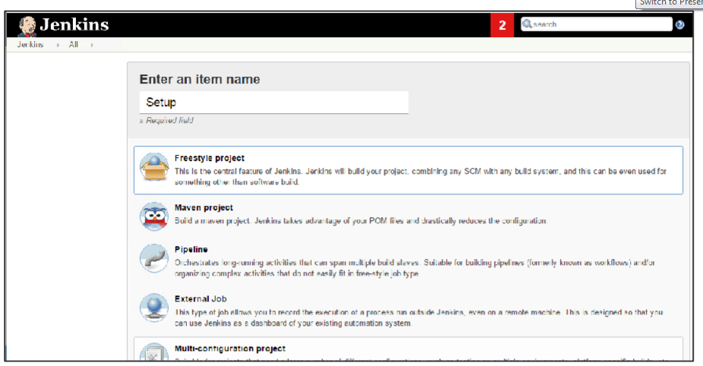

Step 1: Create below mentioned job - Setup

